# Workshop: Petstagram

Throughout the whole module we are going to be creating a **complete Django project** called **"Petstagram"**. The project will cover the following **functionalities**: **registration/login**, user **profile** (with profile picture that can be changed); a user will be able to **view all photos of pets**, open **details**, **comment and like** a photo, **edit** and **delete** their **own** pet photos.

## Final Project

### Home Page

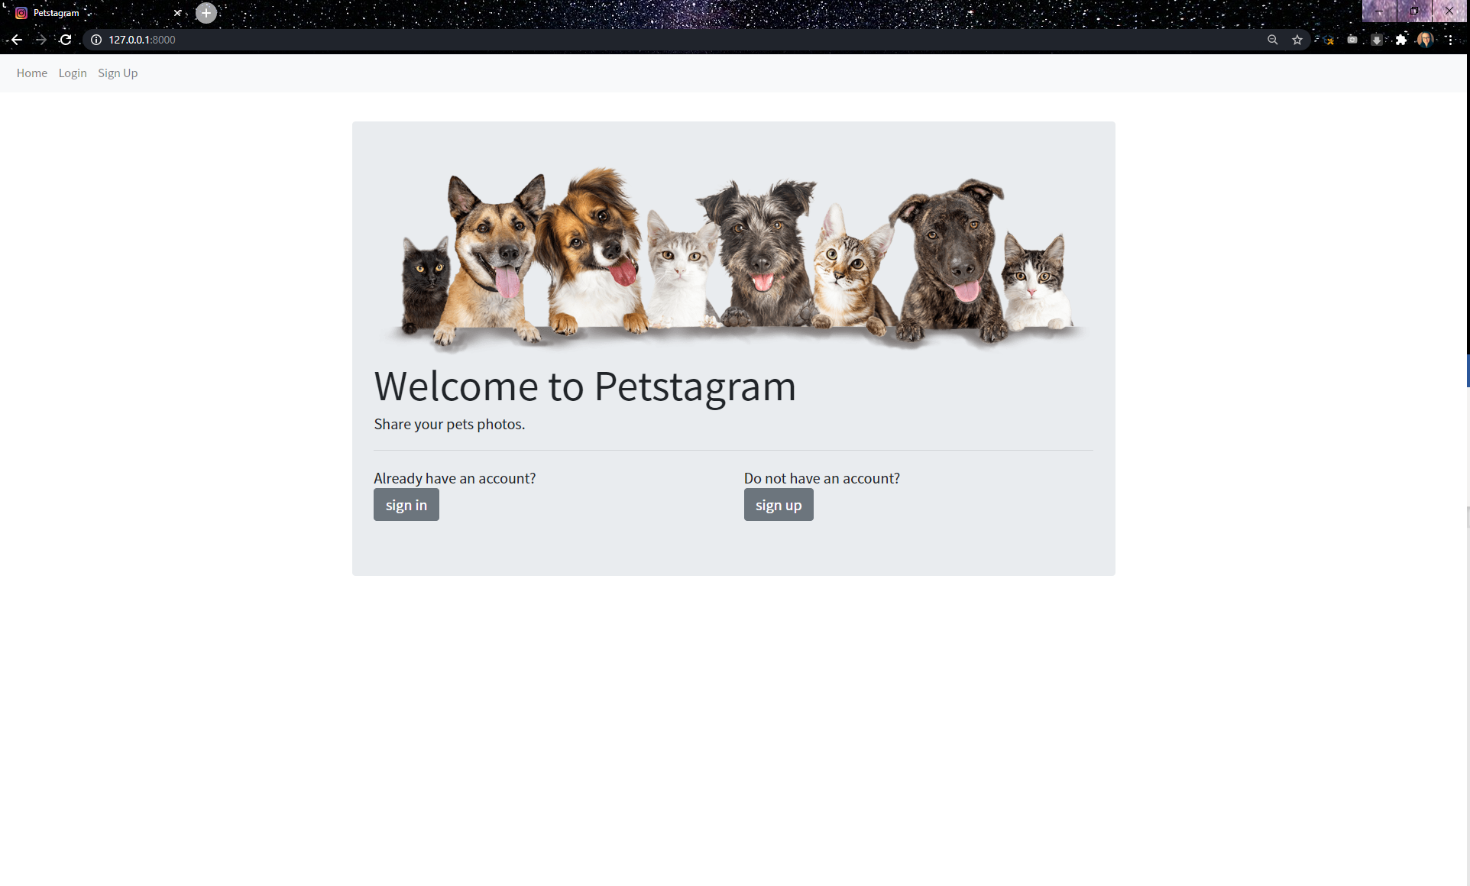

### Register

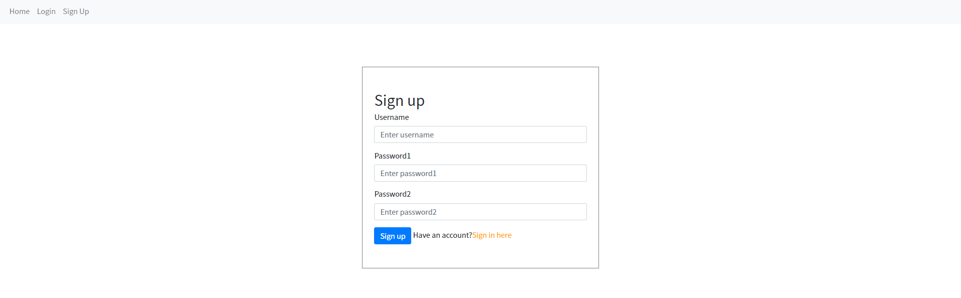

### Login

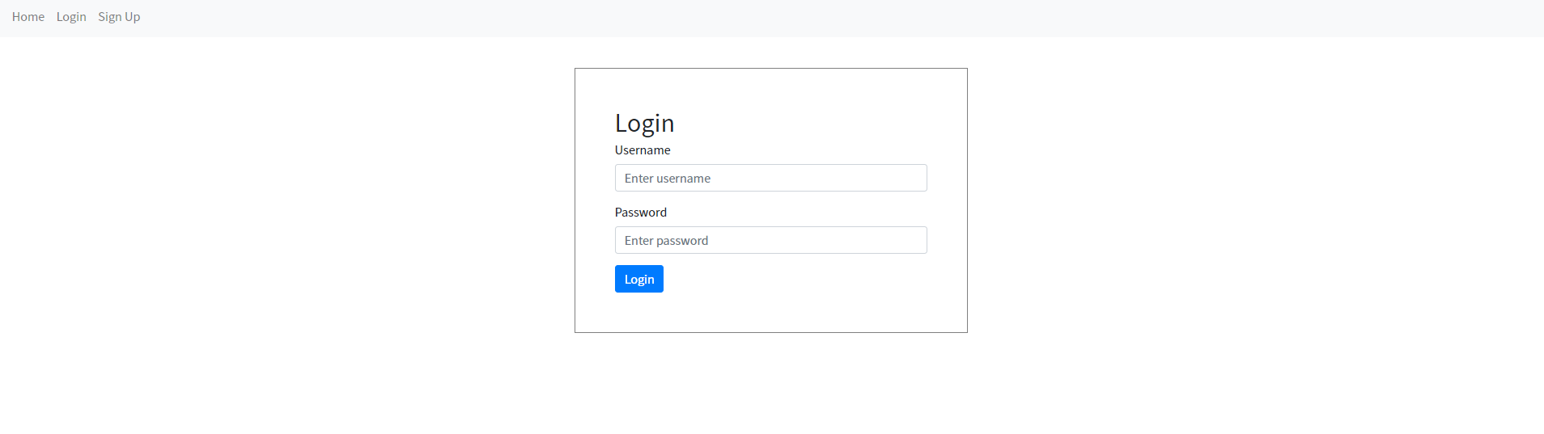

### Create

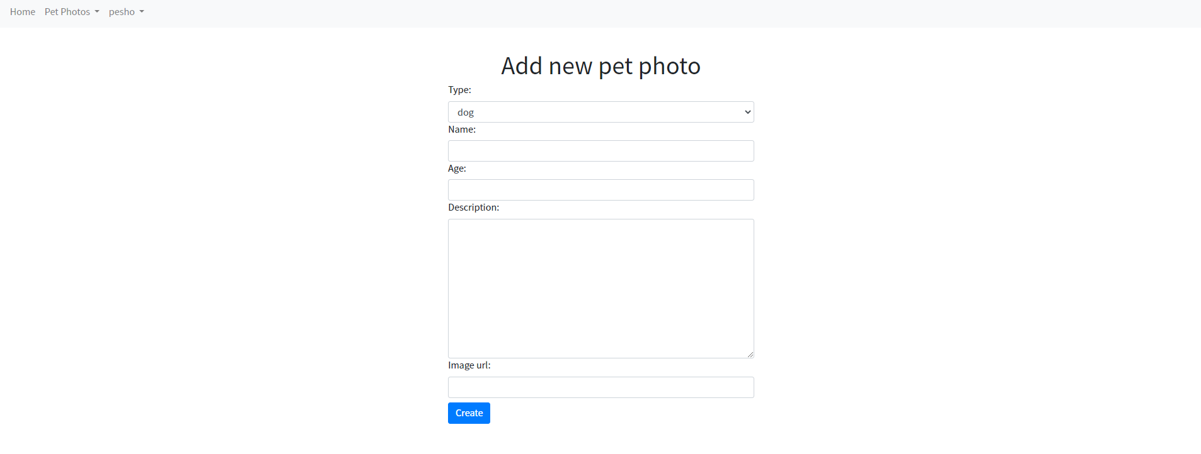

### All Pet Photos

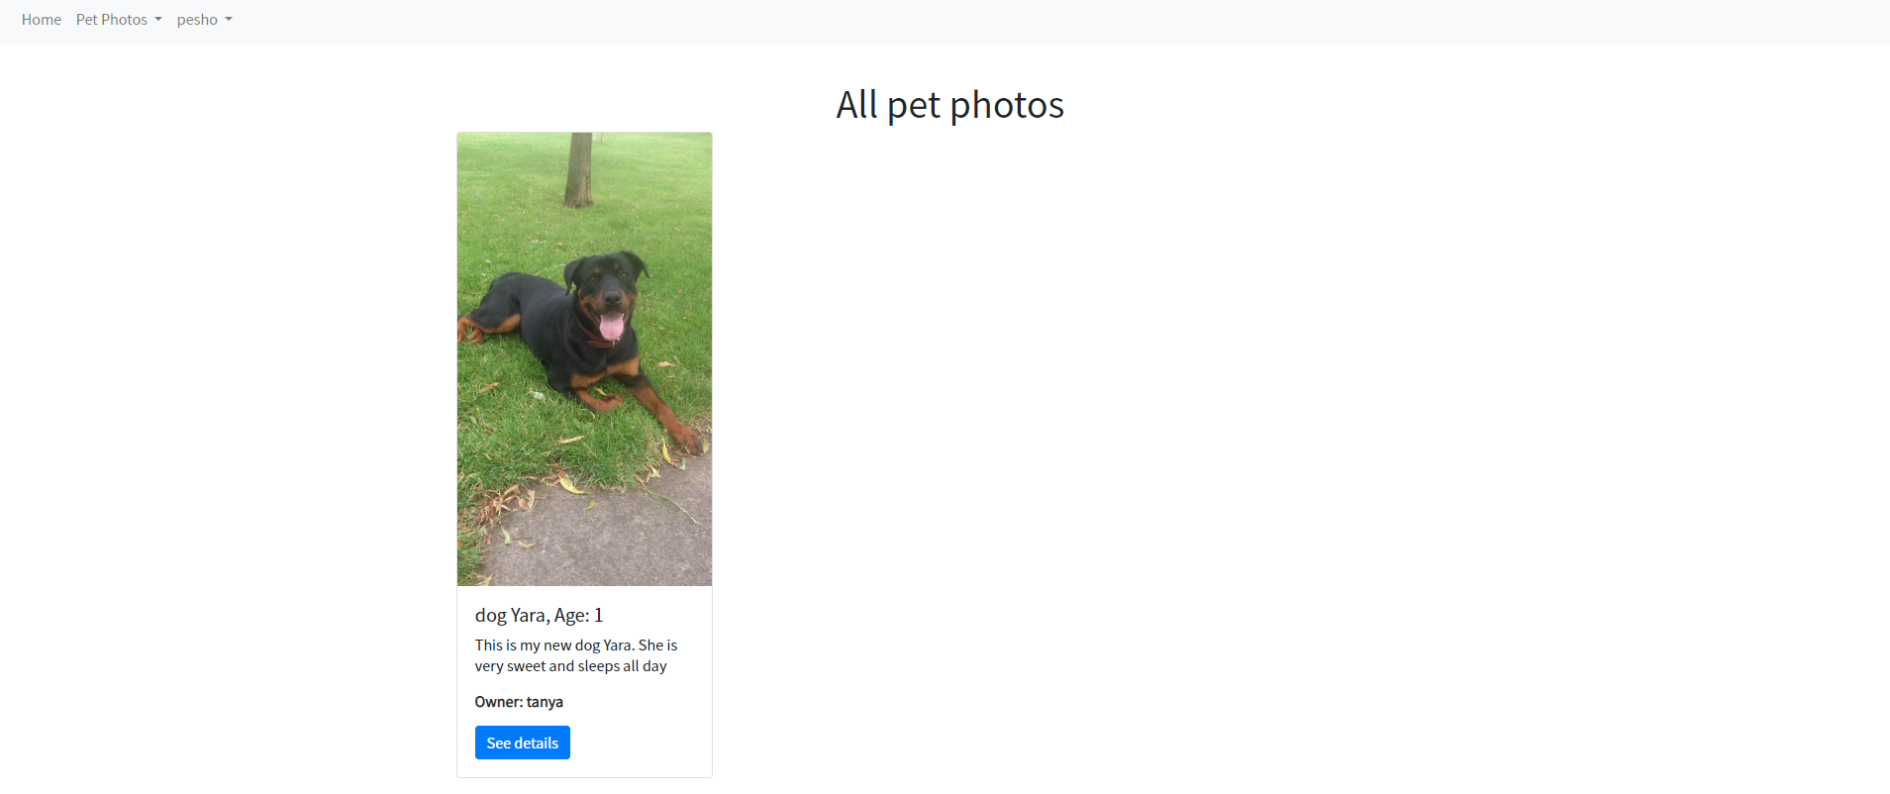

### Pet Details (not own)

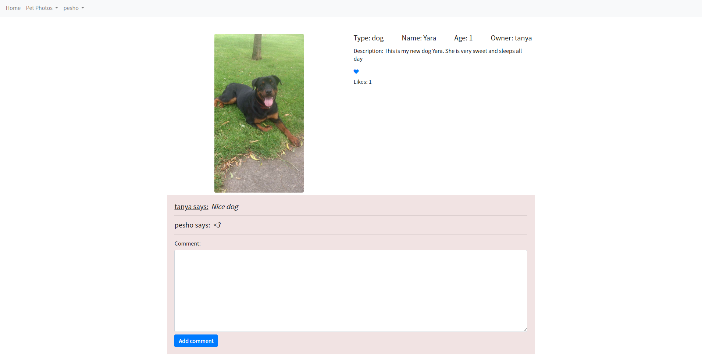

### Pet Details (own)

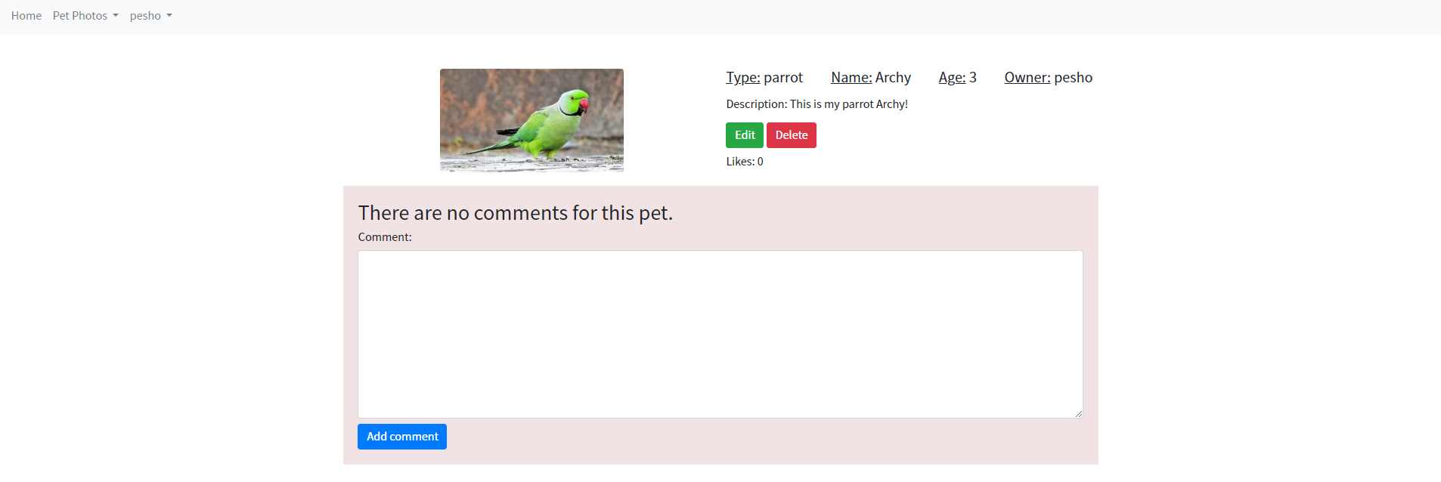

### Pet Edit

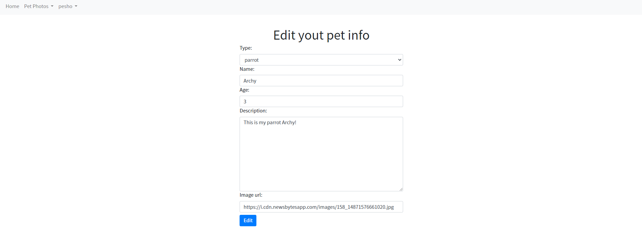

### Pet Delete

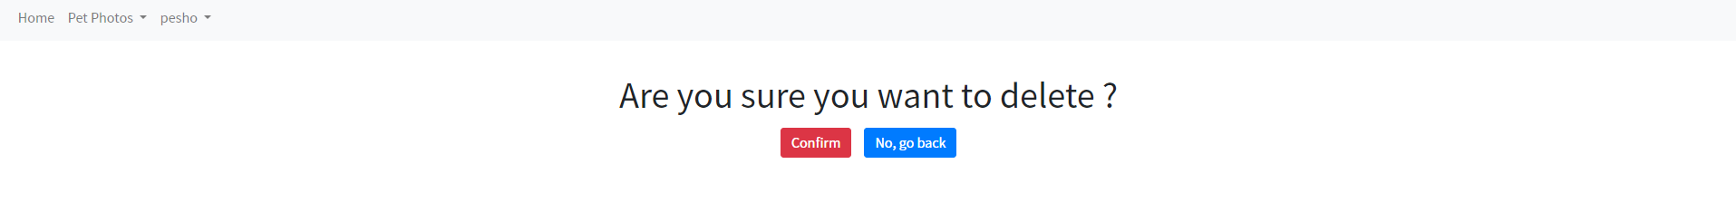

### Profile

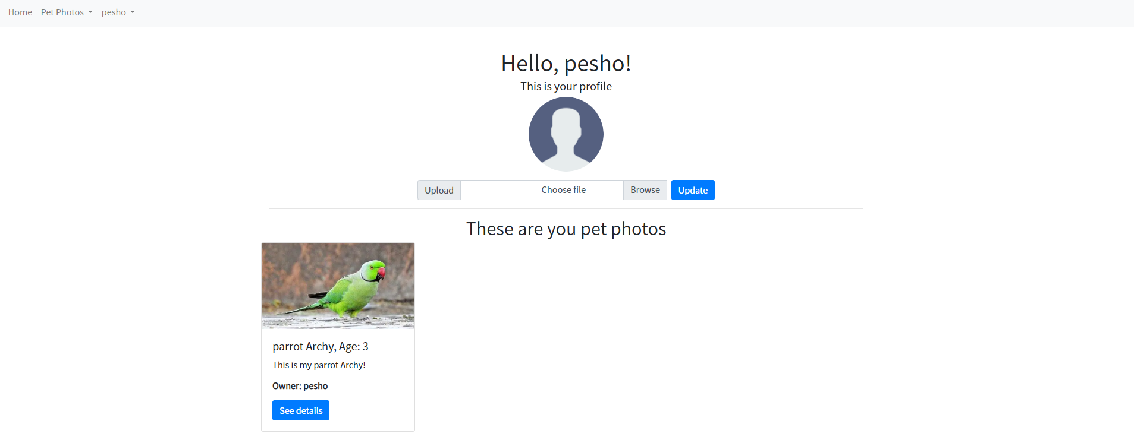

## Part I – The Landing Page

### Setup

Let us start by **creating the project**

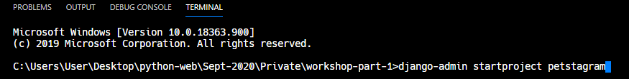

Now, let us create the **first app** which will be called **'common'** which will contain all the **common parts** of our **project**, including the language page



The next step will be to **create** the **templates folder**

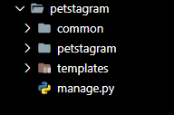

### Configurations

Now, we need to do some **configurations**. We will start with configuring our **templates path**



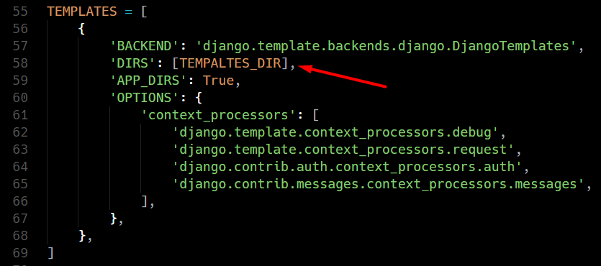

Then, we need to **add the app** we just created in the **INSTALLED_APPS**

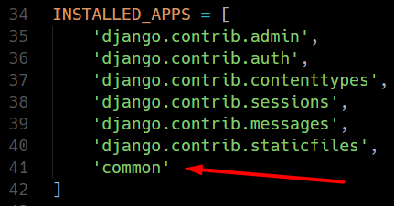

### Migrations and Starting the Project

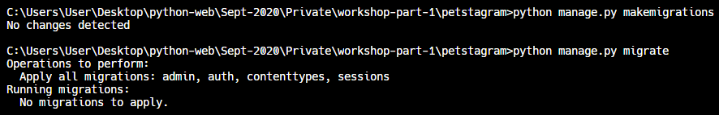

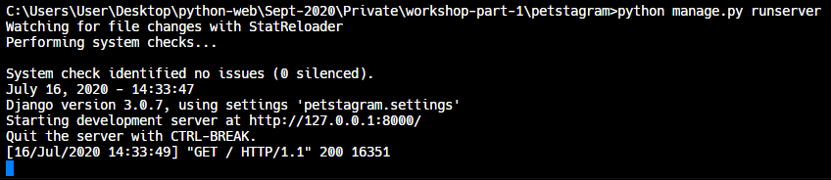

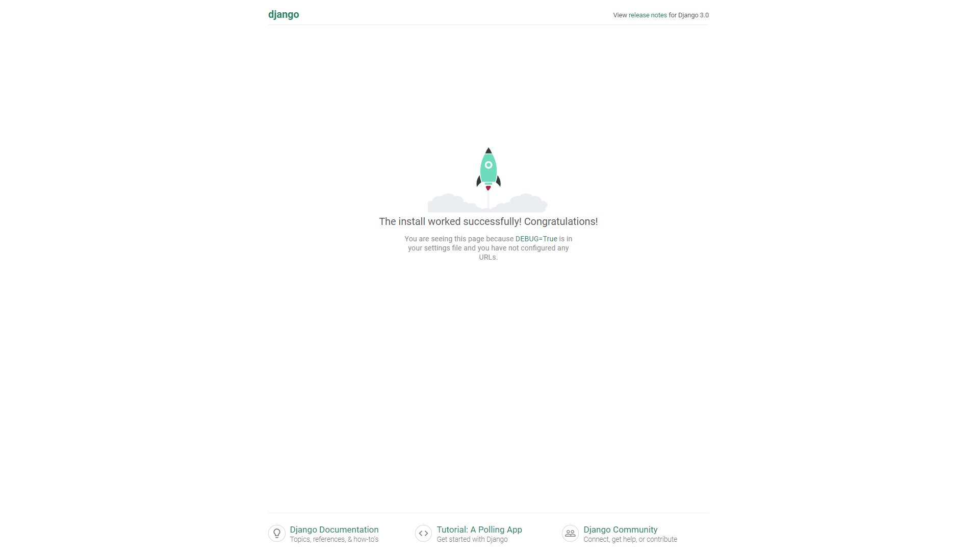

### Creating the Landing Page

Let us first **create** the **html file** of the landing page and write the **html** in it

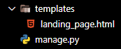

**Copy** the content of the **given html** file and paste it in **your html** file

Now, we can **create the view**

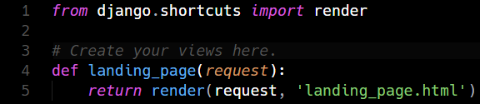

Now, **create** the **urls.py** file and write the following code

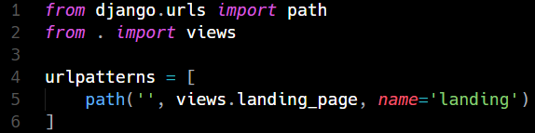

Finally, we need to **include** the **urls** from the app **in** our **project**

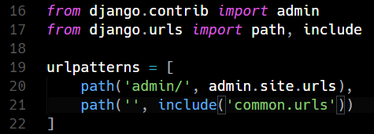

Now we can **start** the **project**

